MS-101 Exam Simulation Notes

Overview
Notes and key topics for the MS-101 Certification Exam.
Contents
Overview 1
12. Microsoft Defender ATP 2
13. What should you do to enable and configure privileged access management? 8
14. Enable unified audit logging. 8
15. You are tasked with implementing the compliance-related features in Microsoft 365 E5 8
16. What steps will be included to implement Azure AD Identity Protection? 8
17. Easiest way to get these Windows devices enrolled in Intune in a Hybrid environment 9
18. Rights Management link is not listed under Service Settings 9
19. What will you suggest as a basic MDM solution to best fit their needs? 9
20. Configuring permissions for Security & Compliance for specific users. 9
21. Management needs information on the backup and protection offered by Office 365. 9
22. Several laptops are missing the last three driver updates. 9
23. Report on Office 365's compliance with the ISO 27001 standard 10
24. All the devices are owned by the tenant. None of the employees will be registering their own devices 10
25. Create a content search report from the Security & Compliance Center in Office365. 10
26. For security, they would like to automate the deployment of apps to college-provided student devices 11
27. Create an information retention policy. 11
28. The Set-RetentionPolicy cmdlet 11
29. Nutex has several users that need specific permissions in Microsoft Store 12
30. What are some available components to help them create a multi-layered security model for their enrolled devices? 12
31. Mailbox Litigation Report 12
32. All documents and emails must have a label 12
33. Dreamsuites would like these devices to connect automatically to the local wireless network, which does not broadcast its SSID. 13
34. The legal department has requested that an alert notification be sent through email when users delete specific files within OneDrive for Business. 13
35. Tag emails with a two-week delete tag. 16
36. Which of the following statements about the records management solution in Microsoft 365 is TRUE? 16
37. What would be a good reporting starting point in the Azure AD Identity Protection Overview? 16
38. Use the Upgrade Readiness solution of Windows Analytics to streamline the process 17
39. As the security admin, you place an infinite hold on those users' mailboxes. What happens when a user both deletes AND purges an item from their mailbox? 17
40. Create a retention policy to delete the content that is older than seven years. 18
41. What should you configure in Cloud Discovery settings so that missing facts about the app will not affect the score in the future? 19
42. Get-Mailbox -ResultSize unlimited | Set-Mailbox -RetentionPolicy "RetentionPolicy-Corp" 19
43. They are especially concerned about protecting valuable files from ransomware. 20
44. using Cloud App Security Defender for Cloud Apps (CAS) to protect selected cloud apps that work with CAS, such as Dropbox 22
45. Microsoft Defender for Cloud Apps 22
46. Verigon Corporation uses Azure Information Protection (AIP) and the Azure Rights Management service to protect Exchange emails and SharePoint files 22
47. You need to ensure that users join and register their Windows 10 devices in Azure Active Directory. Once registered, the device is managed with Intune. 23
48. The desired result is to automatically find, classify, and set policies on high-value data to keep what is relevant and delete stale data. 23
49. They want to take full advantage of the security options available as they update their Windows 10 devices. 23
50. Know when a user deletes files in SharePoint. 23
References 23

12. Microsoft Defender ATP
What steps needed to implement Microsoft defender ATP?
Basic Steps
- Install the Microsoft Monitoring Agent on the Windows 7.1 laptops.
- Configure Security Intelligence updates on the laptops
- Onboard the Windows 10 laptops
More info
- ATP URL: https://Securitycenter.windows.com
- Minimum requirements for Microsoft Defender for Endpoint | Microsoft Docs
- Microsoft Defender for Endpoint (MDATP) webinar: Get started with MDATP | from zero to hero
https://www.youtube.com/watch?v=44lETUWEN50
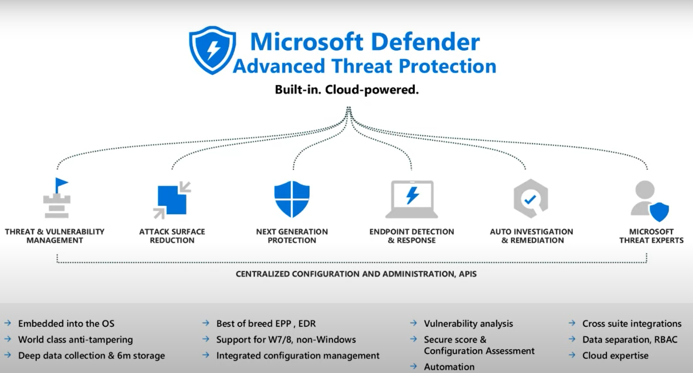
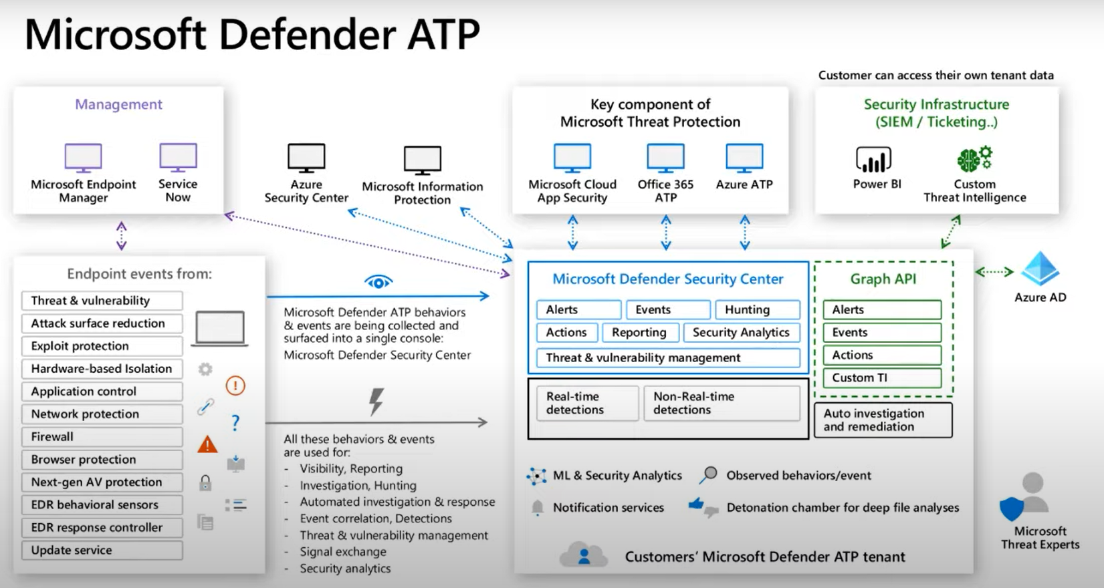
Onboarding & Mnagement
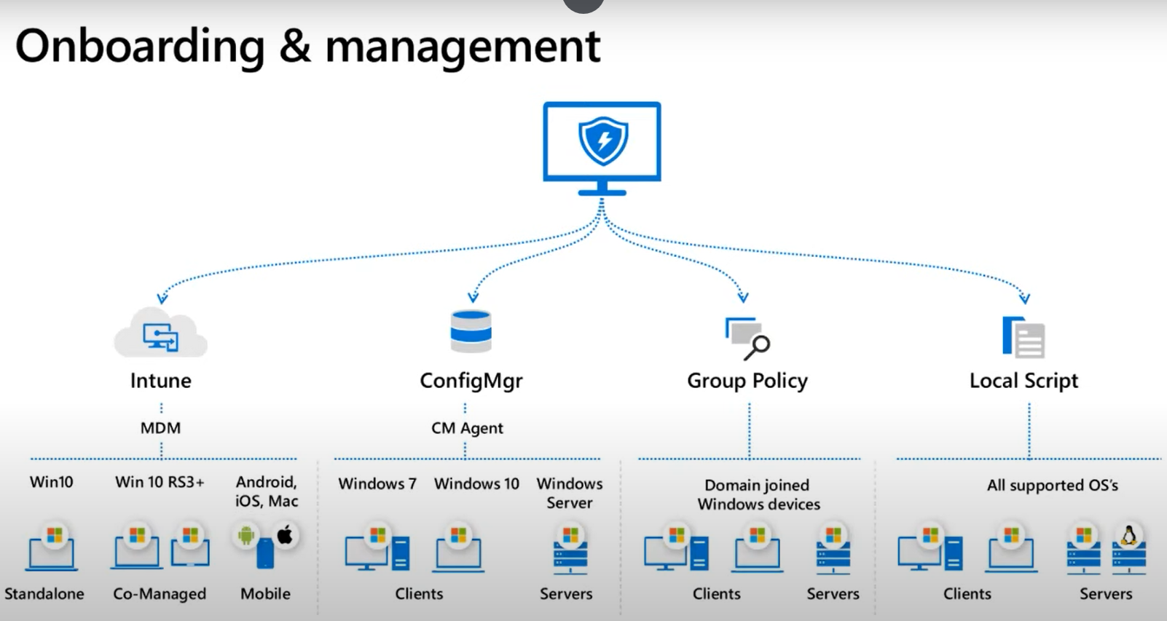
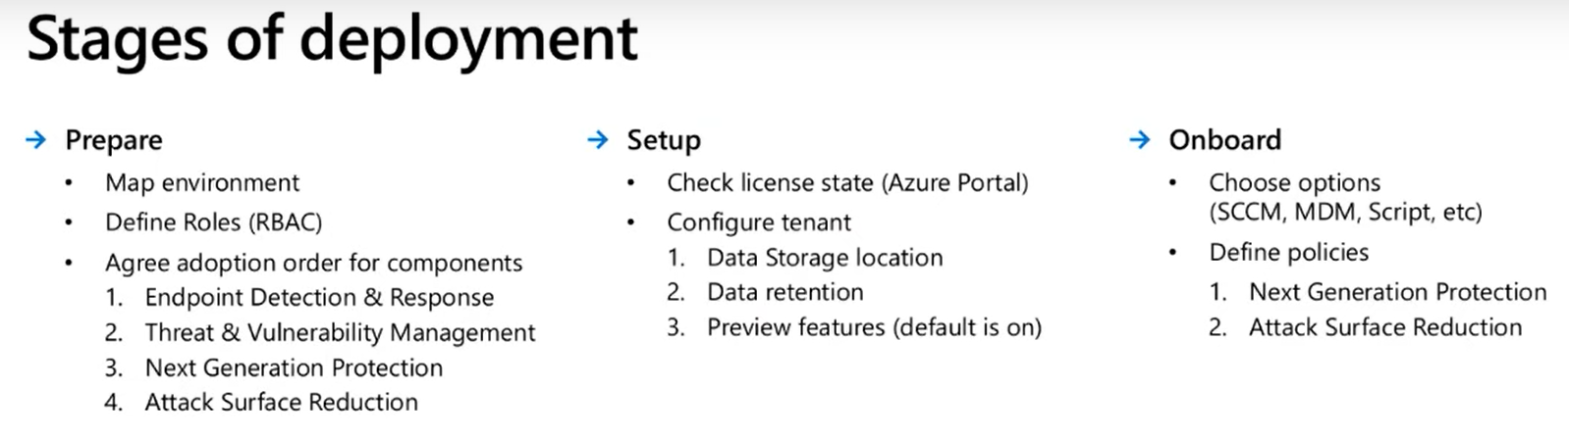
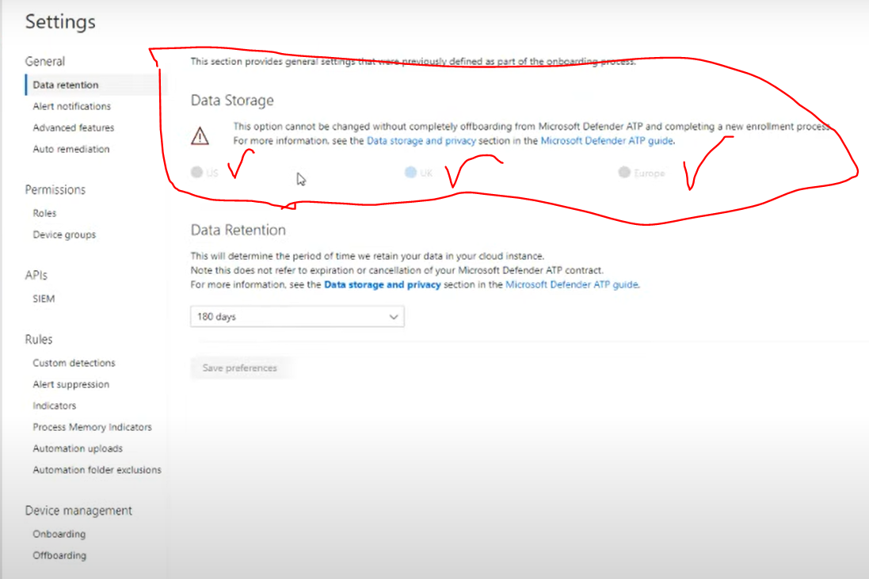
Data Retention in ATP
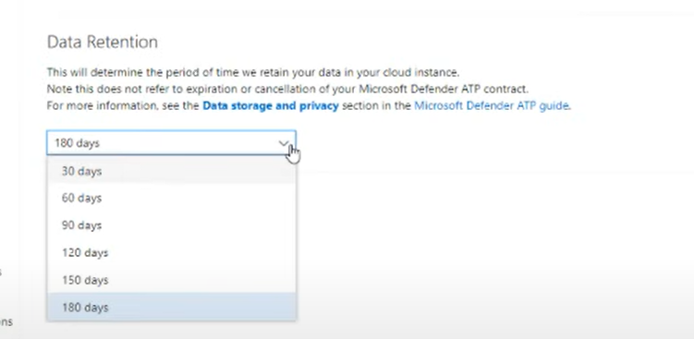
Integration between Endpoint Security (Intune) and Microsoft Defender ATP
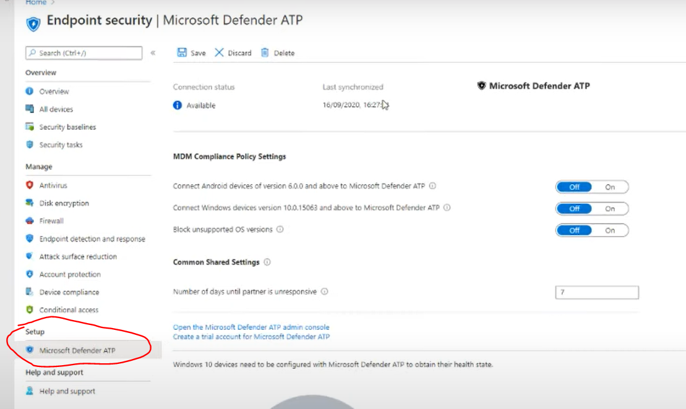
Create a device configuration profile to Onboard Windows devices in ATP
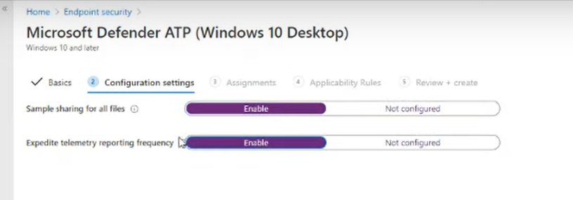
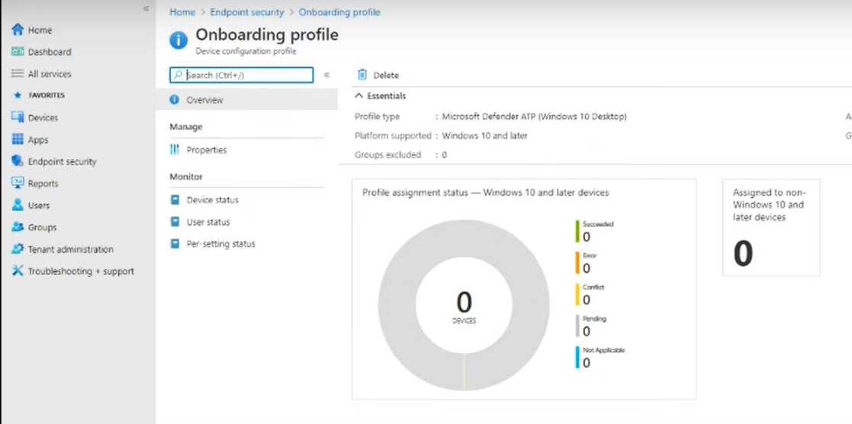
Onboarding
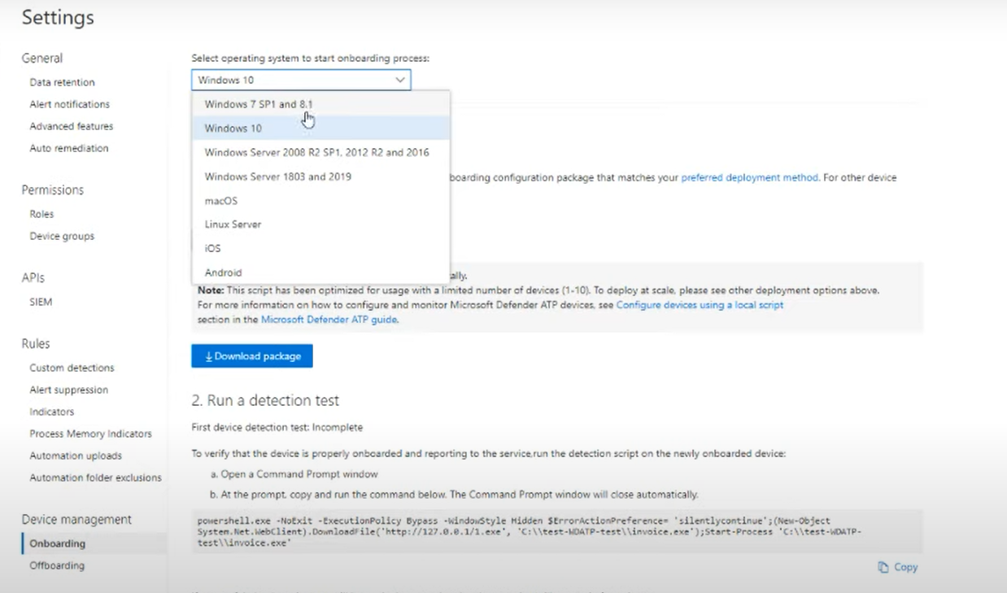
For Windows you do not need to deploy any agent.

13. What should you do to enable and configure privileged access management?
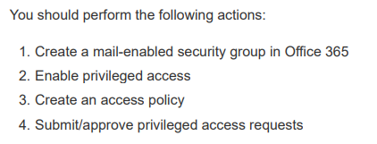

14. Enable unified audit logging.
- Run the PowerShell cmdlet and parameter Set-AdminAuditLogConfigUnifiedAuditLogIngestionEnabled $true
- Run the PowerShell Set-Mailbox -AuditEnabled $True cmdlet and parameter for all mailboxes.
You will need to run the PowerShell cmdlet and parameter Set-AdminAuditLogConfig-UnifiedAuditLogIngestionEnabled $true. This step enables unified audit logging. Auditing can also be enabled under Security and Compliance Center > Search > Audit log search > Turn on auditing
You will need to run the PowerShell Set-Mailbox -AuditEnabled $True cmdlet and parameter for all mailboxes. This enables mailbox logging. Most admin activity for Office 365 is already enabled by default, but mailbox activity logging needs this additional step.

15. You are tasked with implementing the compliance-related features in Microsoft 365 E5
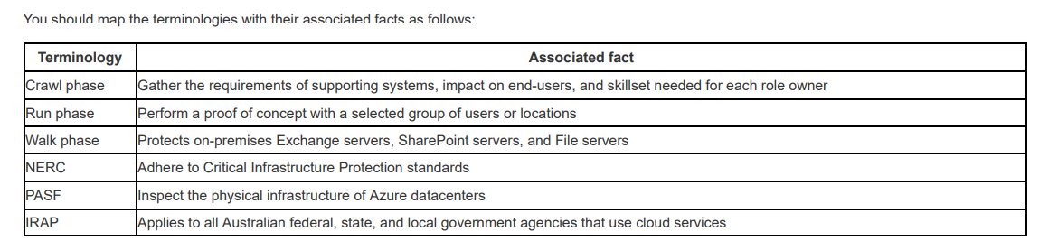

16. What steps will be included to implement Azure AD Identity Protection?
You should choose the following:
- Open the Marketplace in the Azure Portal
- Configure a sign-in risk policy

17. Easiest way to get these Windows devices enrolled in Intune in a Hybrid environment
- Group Policy
Group Policy could, in this scenario, be used to trigger auto-enrollment as all the devices are domain-joined. No user interaction is required. This method requires integration with Azure AD, which Verigon has via Azure AD Connect. Note that once a company has registered its AD with Azure AD, any PC that is domain-joined is automatically AD registered.

18. Rights Management link is not listed under Service Settings
"The attempt to connect to the Windows Azure AD Rights Management (AADRM) service failed".
Why?
- The user has not been added to the Rights Management role
- The company's Office 365 subscription does not include Rights Management.

19. What will you suggest as a basic MDM solution to best fit their needs?
- MDM for Office 365

20. Configuring permissions for Security & Compliance for specific users.
Review

21. Management needs information on the backup and protection offered by Office 365.
- Office 365 includes a Recycle Bin for SharePoint Online sites. Deleted data is kept for 93 days.
- Office 365 includes automatic SharePoint online backup every 12 hours. If data was permanently accidentally deleted, you may be able to ask Microsoft for a backup.
- Office 365 includes SharePoint Online document versioning. You can always restore an older version of a document.
- Office 365 includes the option of maintaining email for legal reasons. This option is now known as Litigation Hold.
- An additional feature is the ability to archive mailboxes forever.
- Office 365 includes the ability to recover Exchange Online deleted items. The items are kept for 14 days by default, but this can be extended up to 30 days, not 90 days.
- At this time, Office 365 does not include the ability to restore Exchange Online mailboxes to a point in time.

22. Several laptops are missing the last three driver updates.
Which updates should be delivered to these laptops?
The latest quality update would bring the devices up to date. This update includes security updates, critical updates, and driver updates. This concept replaces the service pack updates from earlier Windows versions.

23. Report on Office 365's compliance with the ISO 27001 standard
The Service Assurance -Compliance Manager and Service Assurance - Audit Reports would help with the scenario.
The Service Assurance -Compliance Manager section would allow you to verify and document Nutex's compliance with a standard.
The Service Assurance - Audit Reports would be useful as this section allows you to perform a risk assessment of Microsoft's cloud services. You can see the results of independent, third-party audits.
The Information Governance - Dashboard option would not be appropriate for the scenario. This toolbox allows you to classify and manage your content.
The Service Assurance - Dashboard does not meet the requirements. It does, however, give you an overview of the Service Assurance offerings.
The Reports - Dashboard does not meet the requirements of the scenario. However, it does offer information and new insights are added regularly.

24. All the devices are owned by the tenant. None of the employees will be registering their own devices
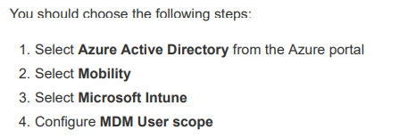
You should not configure the MAM User scope. When you choose the MAM User scope, device uses Windows Information Protection (WIP) Policies (if you configured them) rather than being MDM enrolled. The MAM user scope takes precedence if both MAM user scope for BYOD devices. In this scenario, the devices are corporate-owned and are not BYOD devices.

25. Create a content search report from the Security & Compliance Center in Office365.
The exhibit shows that the items to be EXCLUDED in the report are files that have an unrecognized format, are encrypted , or were not indexed.
The files with FLAC or MP3 extensions were not indexed because of unrecognized formats. MP3, FLAC, or Bitmaps are file types not indexed for search.
A password protected file is not indexed.
A file that is encrypted with non-Microsoft technologies such as the file that is encrypted by another user’s Linux OS is not indexed

26. For security, they would like to automate the deployment of apps to college-provided student devices
Microsoft Intune is the only solution for this scenario due to the variety of operating systems. Intune will need to be chosen as the Mobile Device Management (MDM) via the Azure portal.
You would not use the Microsoft Store for Business, as Windows 10 is a prerequisite and there are other OSes in the scenario. In addition, some of these apps may be line-of-business apps which are apps that are written-in-house.
You would not use the Microsoft Store for Business connected with Microsoft Intune, as Windows 10 is a prerequisite and there are other OSes in the scenario.
In addition, some of these apps may be line-of-business apps. You would not use the Microsoft Store for Education as Windows 10 is a prerequisite and there are other OSes in the scenario. In addition, some of these apps may be line-of-business apps.
You would not use the Azure App Service. This is a service to build and deploy web apps.

27. Create an information retention policy.
You will want to create an information retention policy. In this policy, you can choose to retain data for some time, or after a specific age. You can then further decide to delete the data after retention. This concept could be indirectly achieved with automatically applied retention labels and custom conditions, but this method directly addresses the issue. The implementation uses retention tags vs. retention labels.
You would not create a retention label to retain data that is applied automatically based on a condition. A retention label would require an upgrade to Microsoft 365 E5 to have the label apply automatically. A retention policy can be used to meet the requirement

28. The Set-RetentionPolicy cmdlet
The Set-RetentionPolicy cmdlet is used to modify an existing retention policy. You can use this cmdlet to replace retention tags in a retention policy. If a retention policy already has retention tags linked to it, you can use the -RetentionPolicyTagLinks parameter of the Set-RetentionPolicy cmdlet to replace the existing tags.
Set-RetentionPolicy -Identity "NutexRetPolicy" -RetentionPolicyTagLinks "Finance", "NutexTag1"

29. Nutex has several users that need specific permissions in Microsoft Store
Moe should be a member of the Global Administrator role because he needs to sign up for Microsoft Store for Business and Education, purchase subscription-based software, and purchase apps.
Larry should be a member of the Billing Administrator role because he only needs to purchase apps.
Curley should be a member of the Global Administrator role because he needs to modify the company profile settings.
Betty should be a member of the Signatory role because she needs to be able to sign agreements and view the account for Microsoft Store.
Veronica should be a member of the Billing account role because she needs to be able to sign agreements and view the account for Microsoft Store

30. What are some available components to help them create a multi-layered security model for their enrolled devices?
Intune Device configuration profiles can be used to configure device settings for various platforms. These settings can include device restrictions, device features, email, Wi-Fi, and more.
Intune Device compliance policies are used in combination with Azure AD conditional access policies to check a device for certain settings and then set a compliant flag.
Azure AD conditional access policies apply to Azure AD-joined (and hybrid joined) devices. The policies can be set to include device compliance requirements.
Intune App Protection policies provide an application layer defense that applies to Azure AD accounts. They can be used with or without device enrollment.
Office 365 ATP (Threat Protection Service) is not a mobile device security option. ATP is a cloud-based email filtering service.

31. Mailbox Litigation Report
You have been asked to examine the Office 365 audit logs so that you can determine which mailboxes have been configured to immutably preserve all mailbox items indefinitely.

32. All documents and emails must have a label
Edit the Global policy, and enable the setting "All documents and emails must have a label"
The easiest method will be to edit the Global policy and enable the setting "All documents and emails must have a label". This requirement will apply to all users automatically, so you will just have to add all labels. Each label has the option to be deployed manually by users or to be applied automatically.
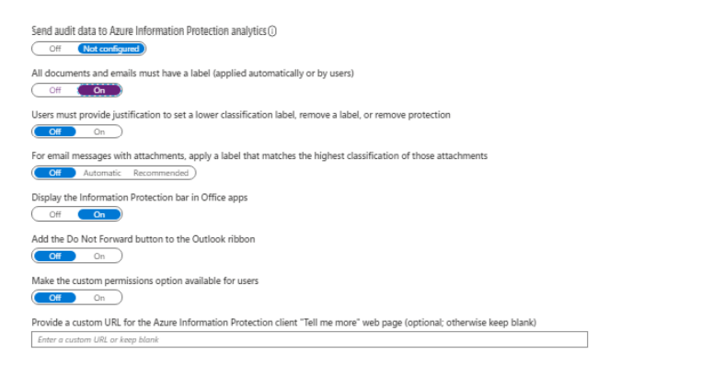

33. Dreamsuites would like these devices to connect automatically to the local wireless network, which does not broadcast its SSID.

You will want to create an Intune IOS device profile. Under Wi-Fi settings, choose Enable for Connect Automatically. This setting is a requirement of the scenario.
You will want to create an Intune IOS device profile. Under Wi-Fi settings, configure SSID. The scenario states that the SSID is not broadcast, so you need this information in the profile.
You will need to go to Device Configuration>Profiles>Assignments and Include the Visitors group. Profiles are inactive until they are assigned.

34. The legal department has requested that an alert notification be sent through email when users delete specific files within OneDrive for Business.

You open the OneDrive admin center
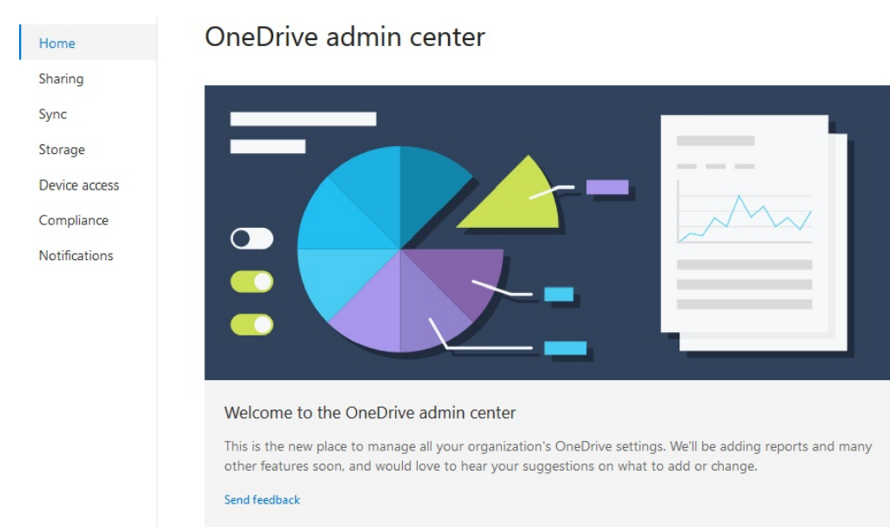
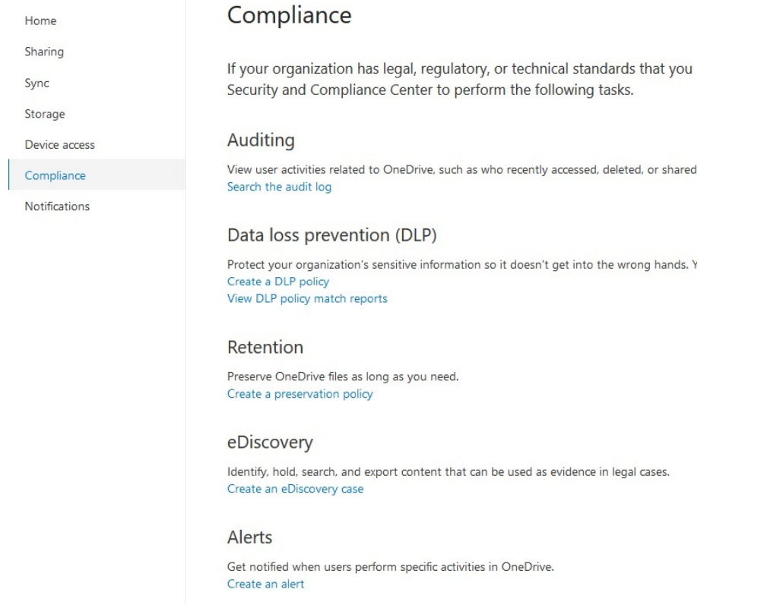

35. Tag emails with a two-week delete tag.
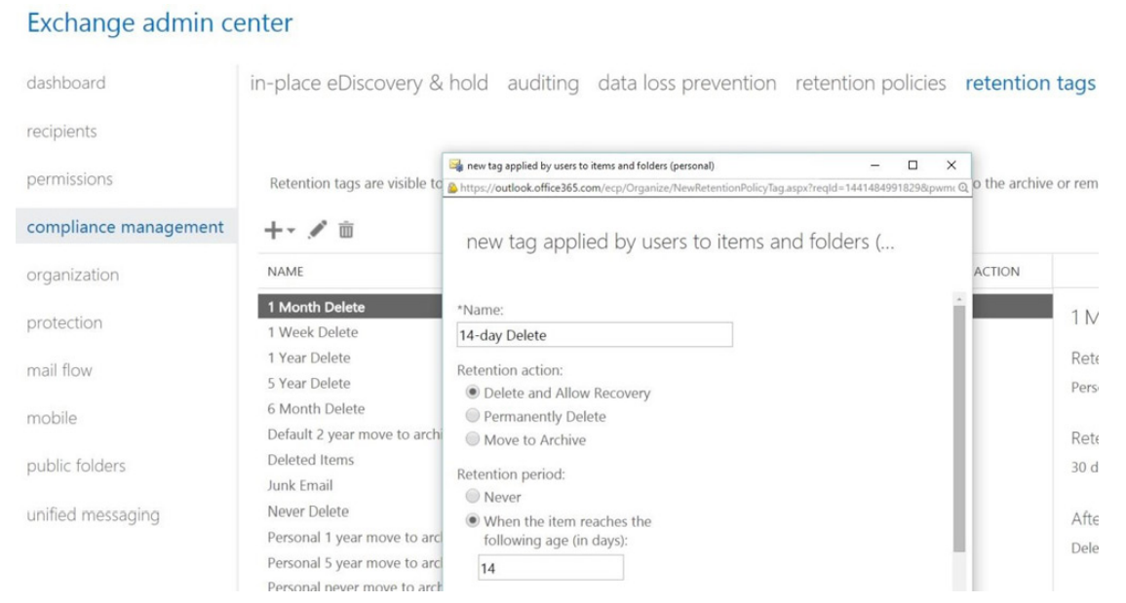

36. Which of the following statements about the records management solution in Microsoft 365 is TRUE?
Content marked as regulatory records can only be read, copied, and moved across SharePoint document libraries, OneDrive accounts, and Exchange mailboxes. This is Microsoft’s definition of a regulatory record. Content in a tenant can be marked as a record or a regulatory record (high-value content). The restrictions placed on the actions performed on the content vary by how they are marked. The restrictions are slightly relaxed for content marked as a record.

37. What would be a good reporting starting point in the Azure AD Identity Protection Overview?
You will want to look at Unprotected Risky Sign-Ins. This report will show you logins that were not MFA-challenged. You could choose to make a policy to block such attempts.
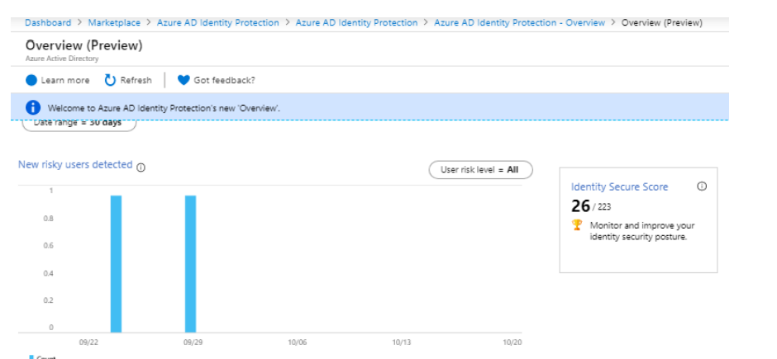

38. Use the Upgrade Readiness solution of Windows Analytics to streamline the process
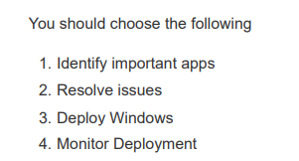

39. As the security admin, you place an infinite hold on those users' mailboxes. What happens when a user both deletes AND purges an item from their mailbox?
The item is moved to the Purges subfolder when the user purges the item. With an indefinite hold, the item will never be removed from the Purges subfolder. If this were an eDiscovery hold, the item would have been moved to a DiscoveryHolds subfolder.

40. Create a retention policy to delete the content that is older than seven years.
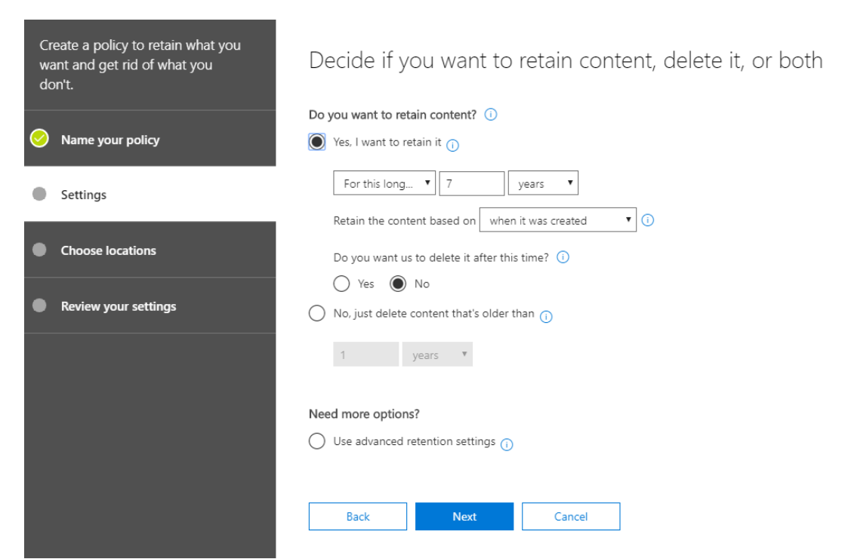

41. What should you configure in Cloud Discovery settings so that missing facts about the app will not affect the score in the future?
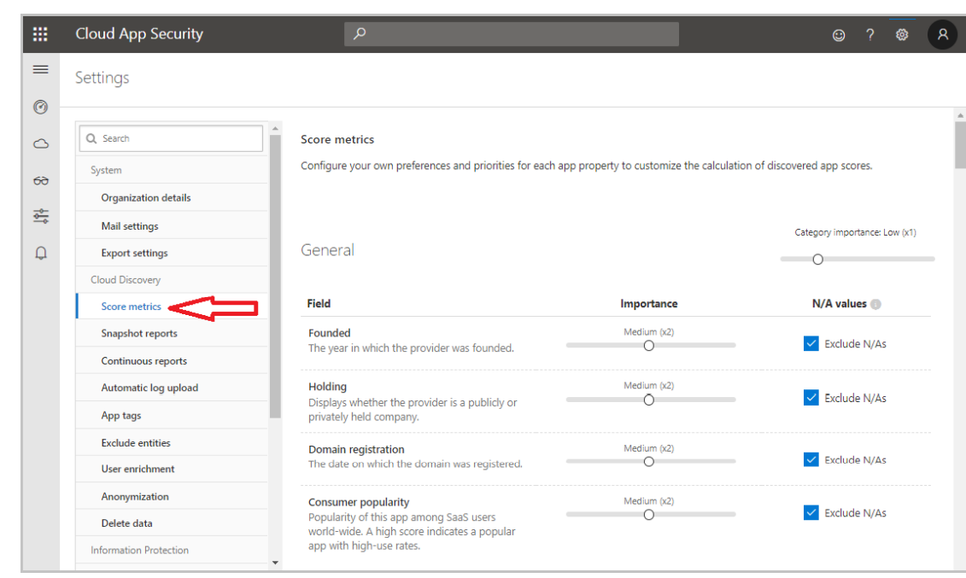
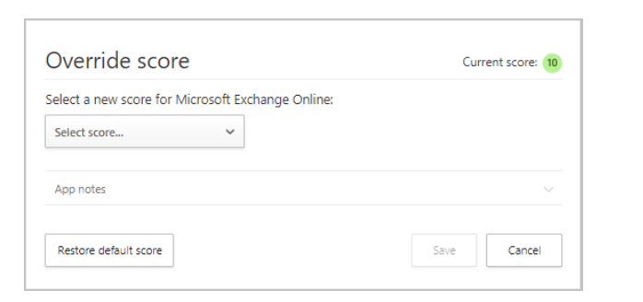

42. Get-Mailbox -ResultSize unlimited | Set-Mailbox -RetentionPolicy "RetentionPolicy-Corp"
What management role group must this employee belong to in order to run the script? (Choose all that apply.)
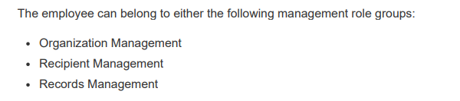

43. They are especially concerned about protecting valuable files from ransomware.
You will want to enable the Real-time protection option of Windows Defender Antivirus. This will provide the "always on" virus scanning desired by Verigon.
You will want to choose the Controlled Folder Access option of Windows Defender Exploit Guard. This will allow Verigon to protect specific files and folders from changes caused by malware or ransomware.
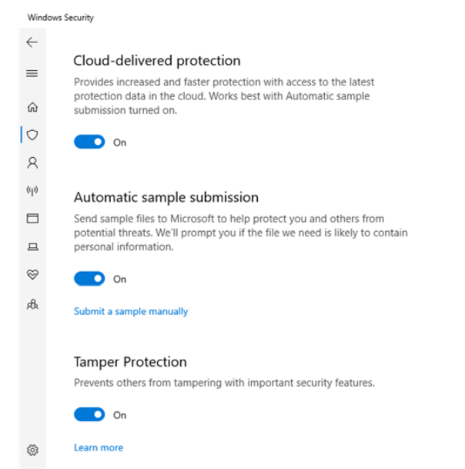

44. using Cloud App Security Defender for Cloud Apps (CAS) to protect selected cloud apps that work with CAS, such as Dropbox
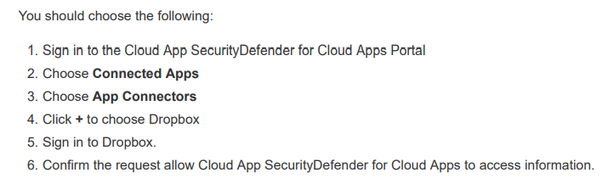

45. Microsoft Defender for Cloud Apps
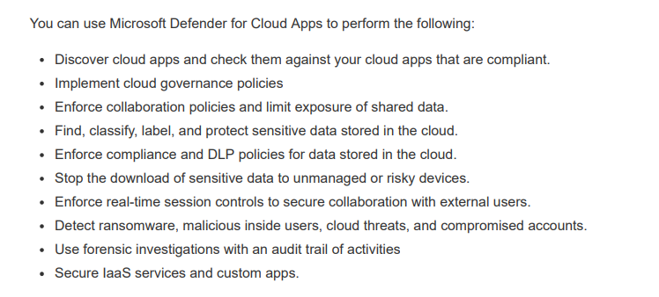

46. Verigon Corporation uses Azure Information Protection (AIP) and the Azure Rights Management service to protect Exchange emails and SharePoint files
They would like members of the HR group to have this power going forward as well as access to other protected content.
- Run the Enable-AipServiceSuperUserFeature cmdlet.
- Run the Set-IRMConfiguration cmdlet, with the -DecryptAttachmentForEncryptOnly parameter.
- Run the Add-AipServiceSuperUser cmdlet and add a user. Run the Set-AipServiceSuperUserGroup cmdlet, and add the HR group

47. You need to ensure that users join and register their Windows 10 devices in Azure Active Directory. Once registered, the device is managed with Intune.
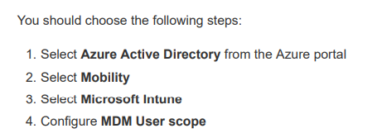

48. The desired result is to automatically find, classify, and set policies on high-value data to keep what is relevant and delete stale data.

The Data Governance section allows the Office 365 administrator to configure the data lifecycle policies, import data from on-premises servers, and apply retention policies. Specifically, the advanced data governance feature will apply machine learning to help determine what data should be kept versus what data is redundant and can be eliminated.

49. They want to take full advantage of the security options available as they update their Windows 10 devices.
Nutex can use Credential Guard, BitLocker to Go, Microsoft Defender for Endpoint, and Unified Write Filter.

50. Know when a user deletes files in SharePoint.
You should create an alert policy from the Security & Compliance center. When you create an alert policy, you can be notified when a specific action is performed by a user, such as deleting a file in a SharePoint site.

References
https://cybersecurityhoy.files.wordpress.com/2022/05/ms-101-exam-simulation.pdf

